b.html

<!DOCTYPE html>

<html lang="en">

<head>

    <meta charset="UTF-8">

    <meta name="viewport" content="width=device-width, initial-scale=1.0">

    <title>Document</title>

</head>

<body style="background-image: url(../images/p2.avif);color: white;background-repeat: no-repeat;background-size: cover;">

    <center><h1>this is BEED page</h1></center>

</body>

</html>

n.html

<!DOCTYPE html>

<html lang="en">

<head>

    <meta charset="UTF-8">

    <meta name="viewport" content="width=device-width, initial-scale=1.0">

    <title>Document</title>

</head>

<body style="background-image: url(../images/p1.avif);background-repeat: no-repeat;background-size: cover;">

    <center>

        <h1>this is NAGAR page </h1>

        <h2>visit to following cities</h2>

        <a href="../beed/b.html"> BEED</a><br><br>

        <a href="../pune/p.html">PUNE</a><br><br>

        <a href="../nashik/n.html">NASHIK</a>

    </center>

</body>

</html>

n.html(nashik)

<!DOCTYPE html>

<html lang="en">

<head>

    <meta charset="UTF-8">

    <meta name="viewport" content="width=device-width, initial-scale=1.0">

    <title>Document</title>

</head>

<body style="background-image: url(../images/p3.avif);background-repeat: no-repeat;background-size: cover;">

   <center> <h1>this is NASHIK page</h1></center>

</body>

</html>

p.html

<!DOCTYPE html>

<html lang="en">

<head>

    <meta charset="UTF-8">

    <meta name="viewport" content="width=device-width, initial-scale=1.0">

    <title>Document</title>

</head>

<body style="background-image: url(../images/p4.avif);color: white;background-repeat: no-repeat;background-size: cover;">

   <center> <h1>this is PUNE page</h1></center>

</body>

</html>

Output screens :

Screen1:

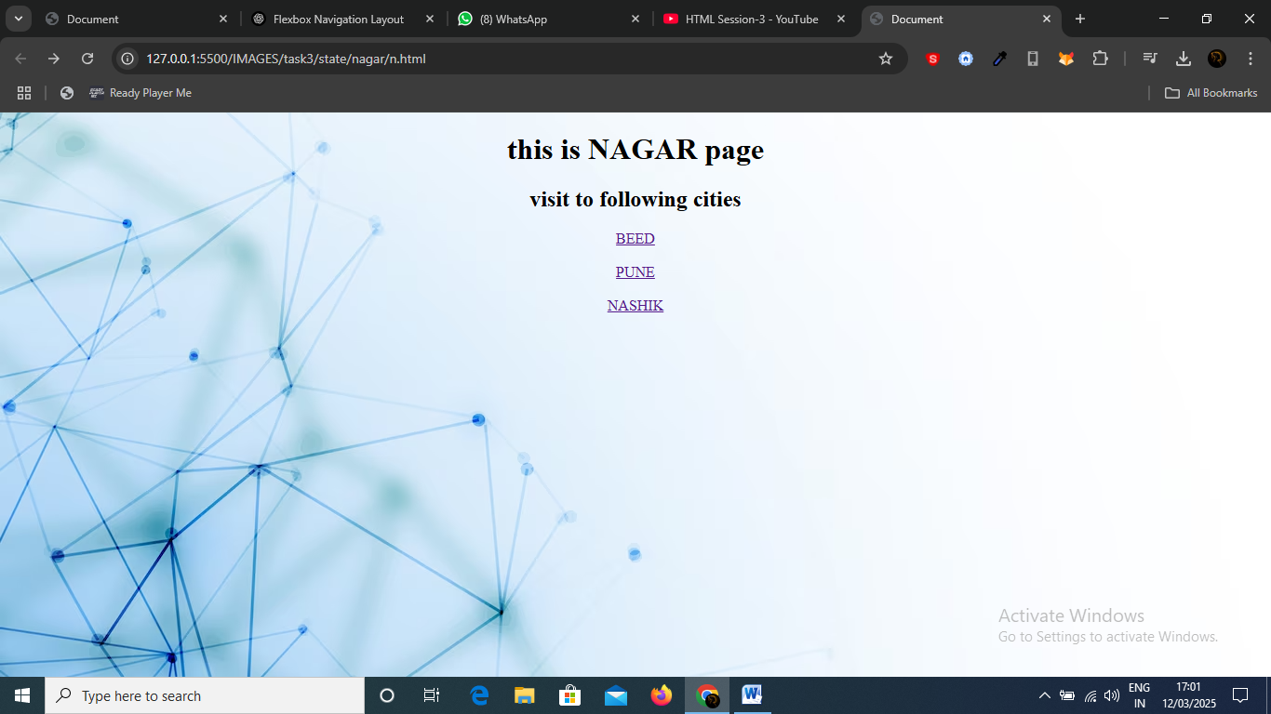

Screen2:

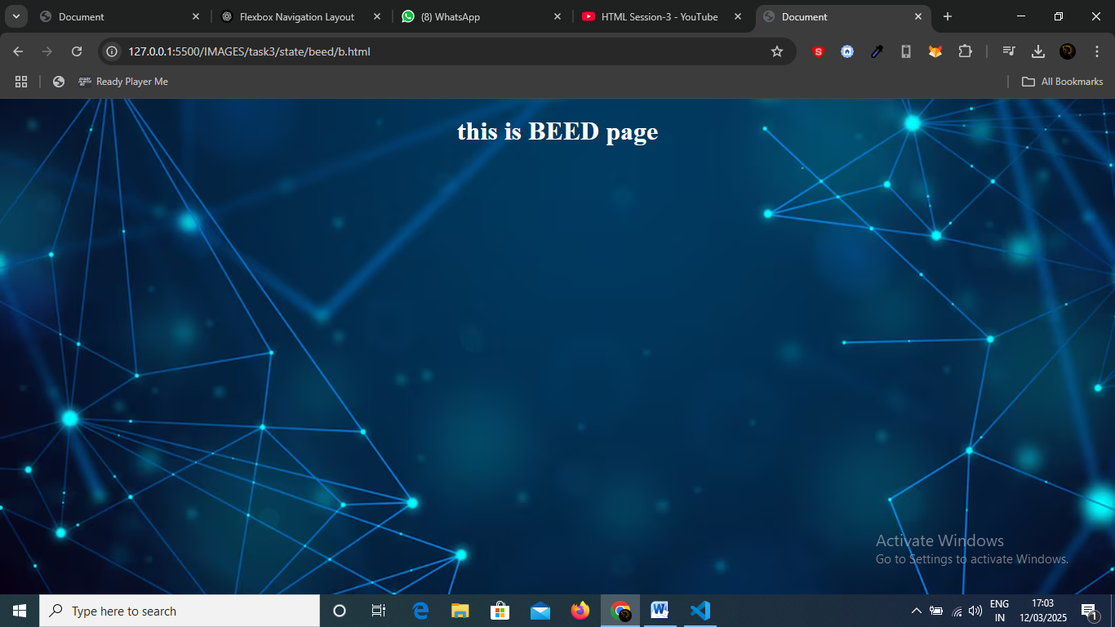

Screen 3:

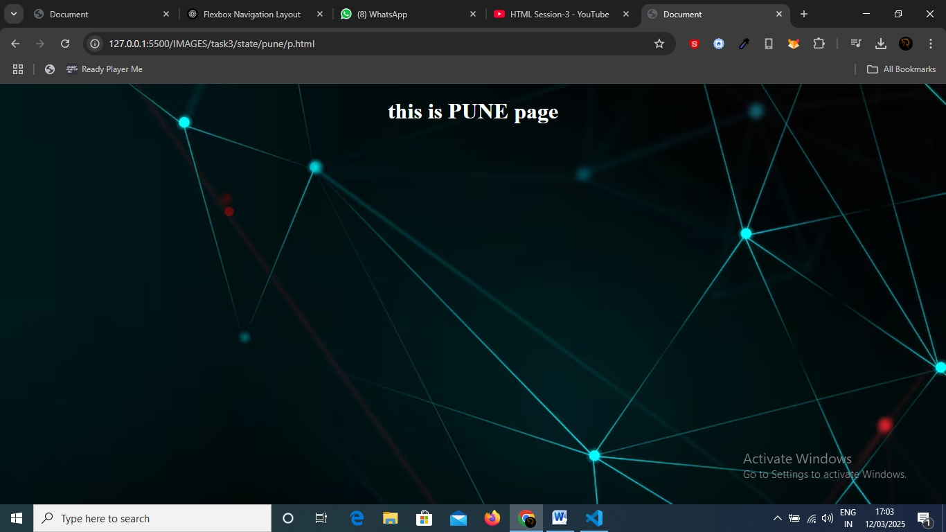

Screen4:

